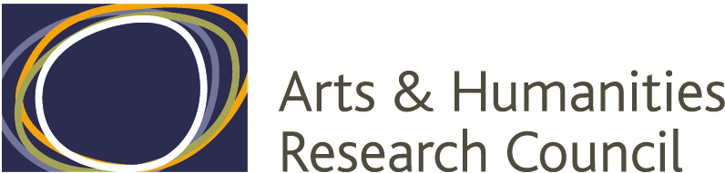

COMMUNICATION, LANGUAGE AND POWER
IN THE ACHAEMENID EMPIRE
The correspondence of the satrap Arshama

Oxford: October 2010 – July 2011

The essential aim of this project (which is funded by the AHRC Research Networking scheme) is to provide the opportunity for detailed, hands-on involvement with one of the most exciting fields in ancient history, Achaemenid Studies. The method adopted will be to push on multiple fronts: the teaching of basic language skills, the exploration of how to look at Achaemenid art, the presentation and discussion of regions or particular bodies of material — with the goal of fostering conversations between archaeologists and philologists, Classicists and Orientalists, graduates and established Achaemenid specialists.

In pursuit of this aim, we propose an interdisciplinary programme of research-centred events, around the corpus of contemporary documents, textual and visual, associated with Arshama, satrap in Egypt in the later years of the fifth century BC. These fascinating documents offer a vivid snapshot of linguistic, social, economic, cultural, organisational and political aspects of the Achaemenid empire as lived by a member of the elite and his entourage. These include land-holding, the extraction and storage of resources, corvée labour, cross-regional ethnic movement, ideologically-driven iconography, religious language and belief, accountancy-culture, long-distance travel, and military systems. The challenge is to examine such topics in detail, but also in the light of the recent advances in the field of Achaemenid studies. These advances are theoretical, methodological, and also documentary and comparative: there is a mass of comparable data from other well-defined documentary contexts. A fully interdisciplinary exploration of the texts and images of Arshama will promote better understanding of the content, manner and limits of provincial government in the Achaemenid empire.

Programme

The programme comprises three categories of activities, which are open to all upon registration by e-mail with the organizers.

Weekly Language Training and Reading of Texts

24 one-hour classes will provide a grounding in the grammar of Achaemenid period Aramaic and the opportunity for close reading of the most important of the Arshama documents. The classes will be run by David Taylor (Oriental Institute, Oxford) and will take place at 1 p.m. on Thursdays during Oxford terms in the Ioannou Centre for the Study of Greek and Roman Antiquity. No previous knowledge of Semitic languages required !

Five one-day workshops and a three-day final conference

Introducing the world of Arshama Saturday 20 November 2010
Achaemenid Art, Text and Images Saturday 29 January 2011
Achaemenid Egypt Saturday 5 March 2011
Travel and Empire Saturday 14 May 2011
The Languages of Empire Monday 4 July 2011
The Arshama Archive: Conclusions and Prospects Tuesday – Thursday 5-7 July 2011

Those speaking at the final conference and one or more of the earlier workshops will be drawn from a group of UK, European and North American participants in the network that includes: Lindsay Allen (London), John Boardman (Oxford), Maria Brosius (Newcastle), Catherine Draycott (Oxford), Lisbet Fried (Ann Arbor), Mark Garrison (San Antonio), Wouter Henkelman (Amsterdam & Chicago), Michael Jursa (Vienna), Deniz Kaptan (Nevada), Arthur Keaveney (Canterbury), Amélie Kuhrt (London), Lloyd Llewellyn-Jones (Edinburgh), John Ma (Oxford), Bezalel Porten (Jerusalem), Karen Radner (London), John Ray (Cambridge), Shaul Shaked (Jerusalem), Peter Thonemann (Oxford), Christopher Tuplin (Liverpool), Caroline Waerzeggers (London), Günter Vittmann (Würzburg).

Exhibition and Public Lecture

The largest component of the corpus of documents associated with Arshama consists of a distinct archive of documents written on parchment that is preserved in the Bodleian Library. There will be an exhibition featuring this archive, and associated material, in the Divinity School running from 28 June – 23 July 2011, and a public lecture on 5 July 2011.

Other observations

An element of the network budget is set aside to provide bursaries to assist postgraduate students based elsewhere in the UK to attend events in Oxford. It is an important aspect of the project’s aims that it should offer postgraduate students (both those on taught MA courses and those already engaged on doctoral work in allied fields) the opportunity to engage with study of the Achaemenid empire in a focused research setting. It may also prove possible to set aside some time in the final conference for presentations by such students.

More precise information about the programme for individual workshops and for the final conference will be available in due course; there is a website with the above information, and much more (http://arshama.classics.ox.ac.uk). In the meantime, please do raise any questions with John Ma (john.ma@ccc.ox.ac.uk) or Christopher Tuplin (c.j.tuplin@liv.ac.uk).

The Arshama Research Network is supported by the AHRC, the Classics Faculty at the University of Oxford, Corpus Christi College, Oxford, the Bodleian Library, and the Beazley Archive.

